Criminal Justice II:
Zoo Research Project & Field Experience Report
An Experiential Learning Initiative in Wildlife Law, Public Safety, and Conservation

Justin Rankin, M.L.A.
Criminal Justice CTE Instructor
Spring 2026
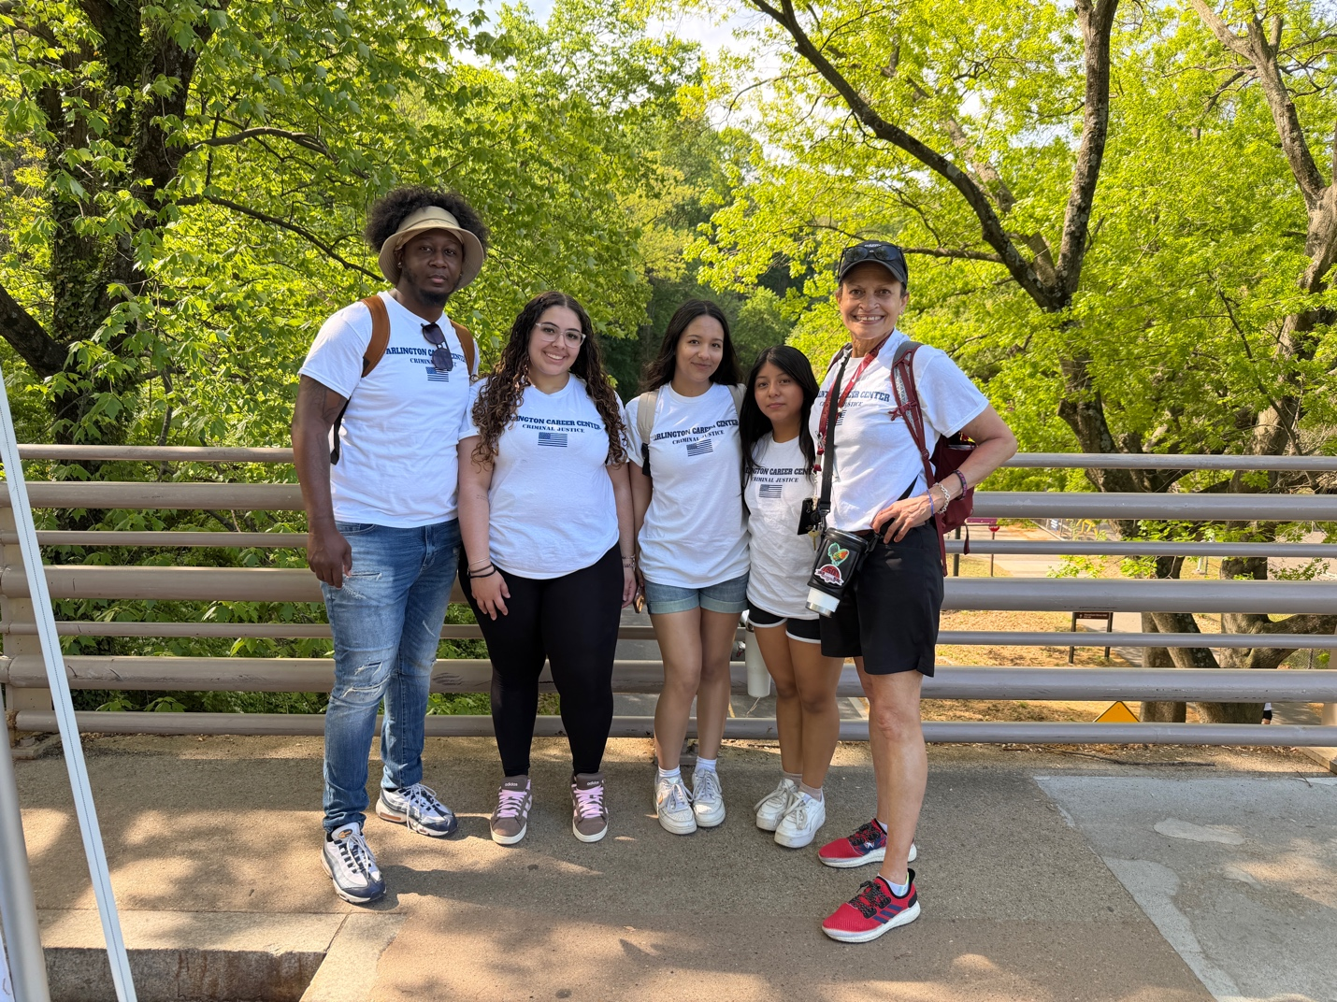

Table of Contents
I. Executive Summary
II. Project Purpose and Rationale
III. Research Questions
IV. Pre-Trip Classroom Preparation
V. Student Roles and Responsibilities
VI. On-Site Observations and Field Notes
VII. Interactions with Zoo Police and Staff
VIII. Analysis of Safety and Security Procedures
A. Security Infrastructure Comparison Matrix
IX. Wildlife Law Connections
A. Key Federal Legislation
B. Criminal Justice Concepts in Wildlife Law
X. Conservation Themes and Criminal Justice Intersections
XI. Student Learning Outcomes and Reflection
A. Measured Outcomes
B. Instructor Reflection
XII. Recommendations for Future Projects
XIII. References
XIV. Appendices
Appendix A: Student Research Question Worksheet
Appendix B: Field Observation Log Template
Appendix C: Photo Documentation Log

I. Executive Summary
The Criminal Justice II Zoo Research Project and Field Experience was designed as a semester-long experiential learning initiative that connected classroom instruction in criminal justice theory with real-world application at a zoological facility. Over the course of the Spring 2026 semester, students investigated the intersection of law enforcement, wildlife protection, public safety, and conservation through structured research, collaborative fieldwork, and reflective analysis. The project was grounded in Career and Technical Education (CTE) standards for the Law, Public Safety, Corrections, and Security career cluster and was informed by Kolb's Experiential Learning Theory, which emphasizes the role of direct experience, reflective observation, and active experimentation in the construction of knowledge.
Key findings from the project demonstrated that students achieved measurable growth in their understanding of wildlife law, non-traditional criminal justice careers, security infrastructure analysis, and collaborative research methodology. Students engaged directly with zoo law enforcement officers, observed security systems in operation, and analyzed how federal legislation—including the Endangered Species Act, the Lacey Act, and the Convention on International Trade in Endangered Species (CITES)—manifests at the facility level. The project reinforced the program's commitment to equity-centered education by ensuring all students, regardless of prior experience or background, had access to meaningful professional exposure and authentic learning opportunities.

II. Project Purpose and Rationale
The Criminal Justice II curriculum is designed to extend foundational concepts introduced in Criminal Justice I, moving students from theoretical understanding toward applied competency. A central objective of CTE programming is to prepare students for career readiness through authentic, work-based learning experiences that mirror the demands of professional environments. The zoo research project was selected because it offered a uniquely rich context in which multiple criminal justice domains converge: law enforcement, legal frameworks, public safety, investigations, and interagency cooperation.
Zoological facilities are complex public institutions where security, regulatory compliance, animal welfare, and visitor safety must be managed simultaneously. For criminal justice students, the zoo environment provides an accessible yet unfamiliar setting in which to observe how policing, jurisdiction, and legal authority function outside of traditional contexts such as patrol, courts, or corrections. This unfamiliarity is pedagogically valuable. It challenges students to transfer their classroom knowledge to a novel environment, strengthening critical thinking and analytical flexibility.

CTE Alignment
This project aligns with the Law, Public Safety, Corrections, and Security career cluster standards, which call for students to demonstrate understanding of security operations, legal systems, and investigative processes. It also supports Virginia CTE's emphasis on high-quality work-based learning (HQWBL) and contextual instruction integrated with career and technical student organization (CTSO) activities.

The project-based learning approach was further grounded in research on experiential education. Kolb (2015) argues that knowledge is constructed through the transformation of experience, and that effective learning requires students to cycle through concrete experience, reflective observation, abstract conceptualization, and active experimentation. The zoo field experience was intentionally designed to move students through each of these stages: pre-trip research and preparation (conceptualization), on-site observation and interaction (concrete experience), post-trip analysis and reflection (reflective observation), and the development of final reports and presentations (active experimentation).
Additionally, the project was designed to broaden students' career horizons by exposing them to non-traditional criminal justice career pathways. Many students enter the Criminal Justice II course with aspirations focused narrowly on patrol policing or detective work. By introducing them to zoo police officers, wildlife inspectors, and conservation enforcement agents, the project expanded their understanding of the criminal justice field and its intersection with environmental science, public policy, and international law.

III. Research Questions
Students were guided by the following research questions, which were developed collaboratively during pre-trip instruction and refined through class discussion. These questions provided a structured framework for on-site inquiry and post-trip analysis.
- What role does law enforcement play in protecting wildlife and ensuring public safety at zoological facilities? This question directed students to examine the scope, jurisdiction, and daily responsibilities of zoo police officers.
- How do zoo police officers apply criminal justice principles in a non-traditional setting? Students explored how foundational concepts such as use of authority, due process, and incident response translate to the zoo environment.
- What federal and state laws govern wildlife protection, and how are they enforced at the zoo? This question grounded students' legal research in observable practice, linking legislation to specific compliance measures at the facility.
- How do security protocols at the zoo compare to those in traditional law enforcement environments? Students conducted comparative analysis between zoo security infrastructure and that of courthouses, schools, and public event venues.
- What connections exist between wildlife conservation efforts and the criminal justice system? This question encouraged interdisciplinary thinking, asking students to consider environmental policy through a criminal justice lens.
- How do zoo staff collaborate with law enforcement agencies to address safety concerns, smuggling, and poaching? Students investigated interagency cooperation and the mechanisms by which zoo personnel coordinate with entities such as the U.S. Fish and Wildlife Service.

IV. Pre-Trip Classroom Preparation
Effective experiential learning requires thorough preparation so that students arrive at the field site equipped with the background knowledge, vocabulary, and analytical tools necessary to engage meaningfully with the environment. The pre-trip phase of this project spanned approximately three weeks of classroom instruction and included the following components:

Introductory Lessons on Wildlife Law
Students received direct instruction on the major federal statutes governing wildlife protection. Lessons covered the Endangered Species Act of 1973, which provides the framework for conserving threatened and endangered species and their habitats; the Lacey Act of 1900, which prohibits trafficking in illegally taken wildlife and imposes both civil and criminal penalties; the Convention on International Trade in Endangered Species (CITES), an international agreement governing cross-border trade in wildlife specimens; and the Animal Welfare Act, which regulates the treatment of animals in exhibition, transport, and research. Students examined the text of selected statutory provisions and discussed how these laws establish jurisdiction, define prohibited conduct, and prescribe penalties.

Case Studies and Scaffolded Activities
To build contextual understanding, students analyzed case studies involving wildlife crime. These included examples of illegal wildlife trafficking rings, poaching investigations, and cases prosecuted under the Lacey Act. Students worked in small groups to identify the applicable laws, the investigative methods used, the roles of various agencies, and the outcomes of prosecution. This case-study approach provided a bridge between abstract legal concepts and the real-world application students would observe at the zoo.
Additional scaffolded activities included:
- Vocabulary-building exercises focused on legal and conservation terminology
- Research methodology training, including instruction on field notetaking, structured observation, and interview protocol
- Pre-trip research assignments in which students investigated the zoo's history, mission, animal collection, and security operations
- Role assignment and team formation, with clear expectations for each team member's responsibilities during the field experience

Differentiated Instruction
Recognizing the diverse learning needs within the class, differentiated instruction strategies were employed throughout the pre-trip phase. Students with varying reading levels were provided tiered reading materials on wildlife law. Visual learners received graphic organizers and infographics summarizing key legislation. English language learners were supported with bilingual glossaries of legal terminology. Students who demonstrated advanced understanding were assigned enrichment tasks, such as comparing U.S. wildlife law to international frameworks in other nations. This differentiated approach ensured that all students entered the field experience with a solid foundation, regardless of their starting point.

Safety Briefing and Expectations
A comprehensive safety briefing was conducted prior to the field trip, covering behavioral expectations, the buddy system, emergency contact protocols, and guidelines for respectful interaction with zoo staff, animals, and fellow visitors. Students reviewed and signed a field trip expectations agreement, and parent or guardian consent was obtained for all participants.

V. Student Roles and Responsibilities
To promote accountability, collaboration, and differentiated engagement, students were organized into research teams of four to five members. Each team member was assigned a specific role with clearly defined responsibilities. This structure ensured that every student had a meaningful contribution to make during the field experience and that the collective research effort was both comprehensive and well-documented.

Role | Responsibilities | Skills Developed
Lead Researcher | Guided the team's inquiry process; ensured research questions were addressed; organized and documented key findings; led post-trip synthesis discussions | Leadership, project management, critical thinking, written communication
Field Observer | Recorded detailed on-site observations using structured field note templates; documented environmental conditions, visitor behaviors, and security features | Observational acuity, descriptive writing, attention to detail, analytical thinking
Photographer / Documentarian | Captured visual evidence of security measures, animal exhibits, signage, and team interactions; maintained a photo documentation log with captions and timestamps | Visual documentation, digital literacy, organizational skills, storytelling
Interviewer | Prepared and conducted semi-structured interview questions for zoo police officers and staff; recorded responses and clarified information in real time | Interpersonal communication, active listening, interview technique, professional etiquette
Safety Analyst | Evaluated physical security infrastructure including fencing, barriers, surveillance cameras, access control points, and emergency signage; compared features to traditional law enforcement environments | Security assessment, comparative analysis, spatial awareness, report writing

Role assignments were made with attention to student strengths, interests, and areas for growth. Students who expressed interest in careers in criminal investigation, for example, were encouraged to take on the Interviewer or Lead Researcher roles, while students with strengths in visual arts or technology were well-suited to the Photographer/Documentarian role. This intentional alignment between student identity and role assignment supported engagement and provided each learner with an authentic, career-connected experience.

VI. On-Site Observations and Field Notes
The field experience day was structured to maximize student engagement while allowing sufficient time for careful observation, documentation, and interaction with zoo personnel. Upon arrival, students assembled by research team, reviewed their assigned research questions, and confirmed role responsibilities. The instructor provided a brief orientation that situated the day's activities within the broader arc of the research project.

Animal Habitats and Exhibit Design
As students moved through the zoo, they observed a wide range of animal habitats designed to simulate natural environments while maintaining containment and visitor safety. Field observers noted the use of moats, tempered glass barriers, elevated walkways, and naturalistic fencing to separate animals from the public. Students documented how exhibit design reflected a dual priority: animal welfare and human safety. Several teams noted that the physical barriers at large predator exhibits such as those housing big cats and bears were substantially more robust than those at exhibits for smaller herbivores, reflecting a risk-based approach to containment.

Visitor Management and Crowd Control
Students observed visitor management strategies throughout the facility, including directional signage, designated pathways, capacity limits at popular exhibits, and the visible presence of uniformed security personnel. Safety analysts noted the strategic placement of emergency call boxes and first aid stations, as well as the use of public address systems for announcements. Several students drew parallels between the zoo's crowd management techniques and those used at large public events such as concerts, sporting events, and community festivals environments they had studied in earlier Criminal Justice II units on public safety.

Signage and Legal Messaging
A notable observation across multiple teams was the prevalence of signage related to wildlife law and conservation. Students documented signs referencing the Endangered Species Act, CITES trade restrictions, and state-level wildlife protection statutes. Educational displays at several exhibits described the species' conservation status, the threats they face in the wild (including poaching and habitat destruction), and the legal protections in place. Students recognized that the zoo served not only as a recreational and scientific institution but also as a public education platform for wildlife law awareness.

Security Infrastructure
Safety analysts conducted systematic assessments of the zoo's physical security features. Observations included perimeter fencing with controlled access points, closed-circuit television (CCTV) cameras positioned at high-traffic areas and sensitive locations, security checkpoints at entry gates, and vehicle barriers at service entrances. Students noted the integration of visible and discrete security measures—uniformed officers provided a deterrent presence, while surveillance cameras and access control systems operated in the background. This layered approach to security was later compared to security models studied in the classroom.

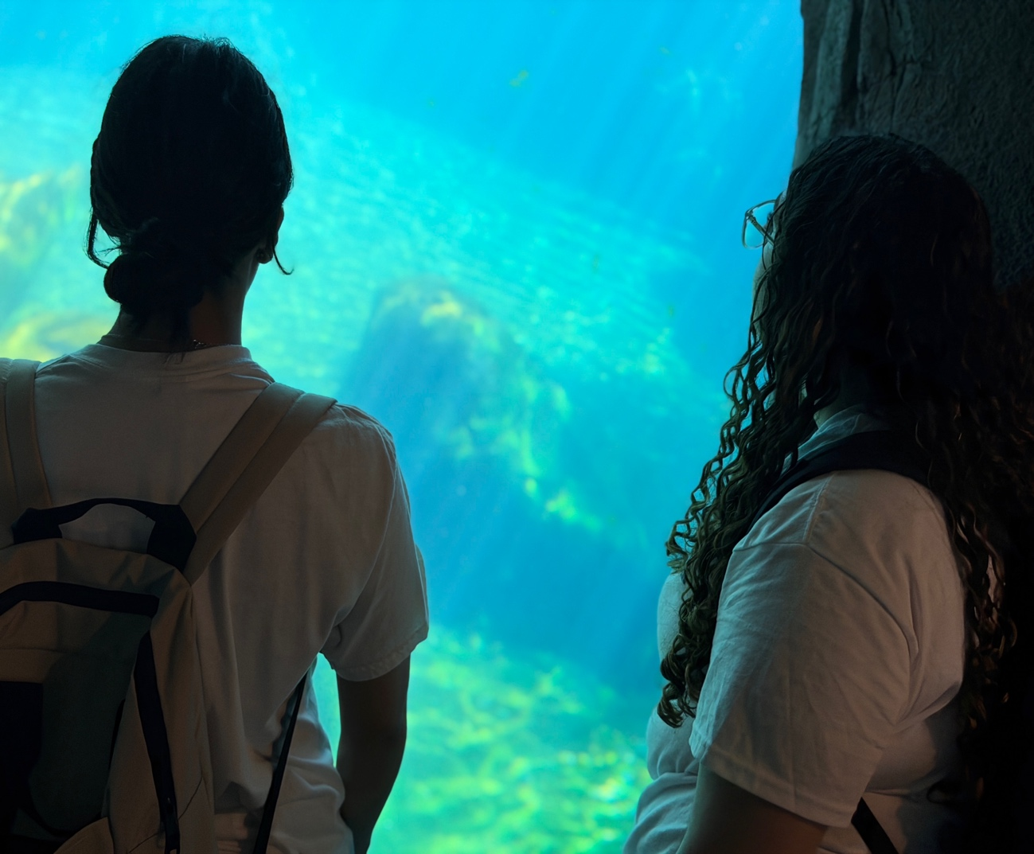

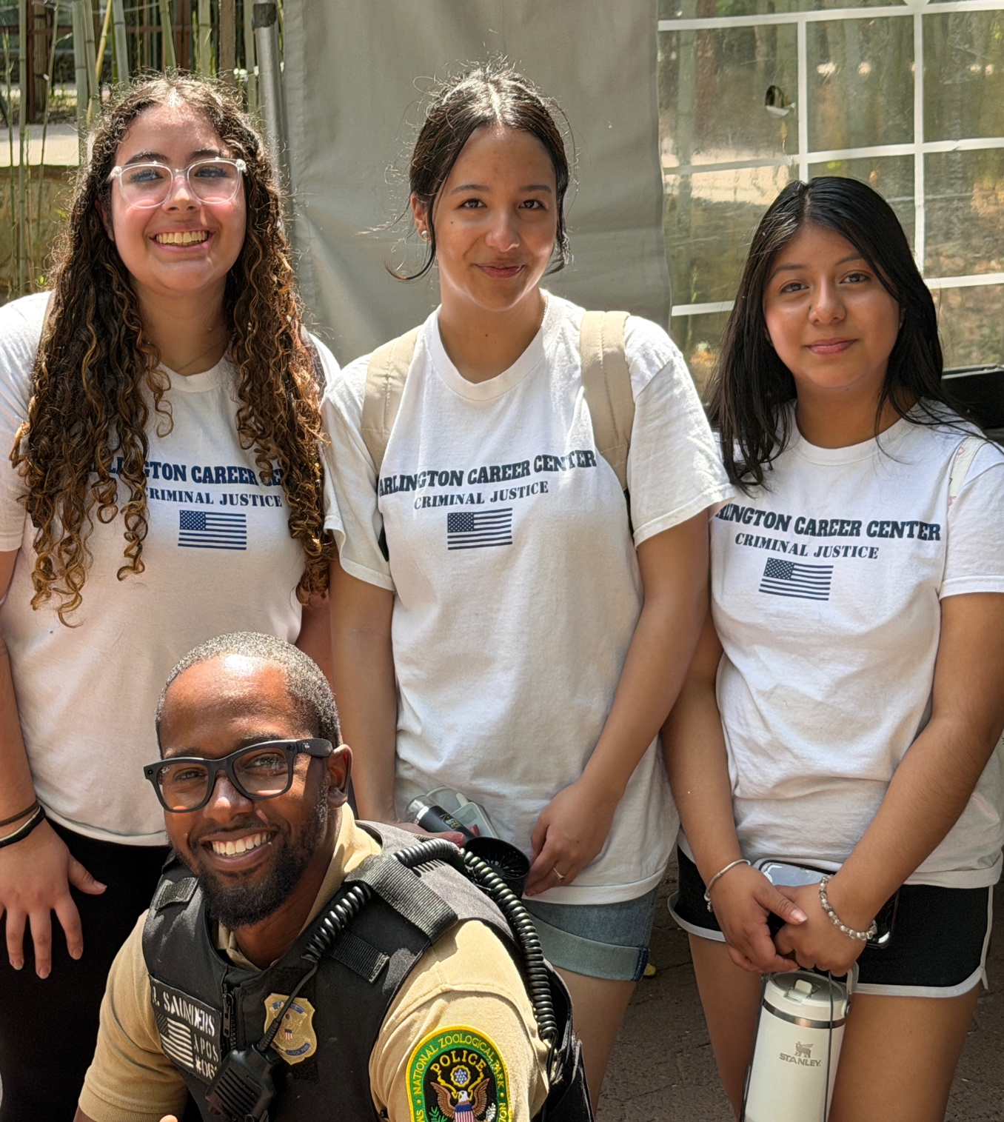

VII. Interactions with Zoo Police and Staff
One of the most impactful components of the field experience was the opportunity for students to interact directly with zoo law enforcement officers and other staff members. These interactions were facilitated through pre-arranged informational sessions as well as organic conversations that occurred throughout the day.

Zoo Police: Daily Duties and Training
Students learned that zoo police officers perform a wide range of duties that blend traditional law enforcement functions with specialized responsibilities unique to the zoological setting. Officers described their daily activities, which include facility patrols, visitor assistance, incident response (medical emergencies, altercations, theft), enforcement of zoo regulations, and coordination with animal care staff during exhibit maintenance and animal transfers. Students were particularly interested to learn about the training requirements for zoo police, which include standard law enforcement academy certification as well as specialized instruction in animal behavior, chemical immobilization protocols, and wildlife law.

Jurisdiction and Authority
Interviewers posed questions about the jurisdictional scope of zoo police authority. Officers explained that their jurisdiction is typically limited to zoo property but that they maintain mutual aid agreements with local municipal police departments and coordinate with federal agencies particularly the U.S. Fish and Wildlife Service on matters involving protected species, suspected trafficking, or violations of federal wildlife statutes. Students noted that this jurisdictional framework was more complex than they had anticipated, reflecting the layered nature of law enforcement authority that they had studied in their textbook but rarely seen in practice.

Incident Response and Emergency Protocols
Zoo police officers described their protocols for responding to a range of incidents, from visitor injuries and lost children to the most critical scenario: an animal escape. Students learned about the zoo's incident command structure, which mirrors the National Incident Management System (NIMS) used across emergency management. Officers explained that animal escape drills are conducted at least twice annually and involve coordinated responses from security, animal care, veterinary staff, and external law enforcement. The use of a centralized communications hub, weapons teams, and clearly defined perimeter security responsibilities underscored the complexity and seriousness of these protocols.

Key Finding
Students reported that their interactions with zoo police officers significantly broadened their understanding of criminal justice career pathways. Multiple students indicated that prior to the field experience, they had not been aware that law enforcement careers existed within zoological and conservation settings. This finding validates the project's goal of expanding career awareness beyond traditional policing roles.

Coordination with External Agencies
Staff members described their working relationships with external agencies, including the U.S. Fish and Wildlife Service, state game wardens, the U.S. Department of Agriculture (USDA) Animal and Plant Health Inspection Service (APHIS), and local law enforcement. Students learned that the zoo is subject to regular USDA inspections under the Animal Welfare Act and that compliance with federal regulations is a significant operational responsibility. Conversations about interagency cooperation gave students a practical understanding of how multiple levels of government collaborate to enforce wildlife protection laws—a concept that can feel abstract in the classroom but became tangible through these discussions.

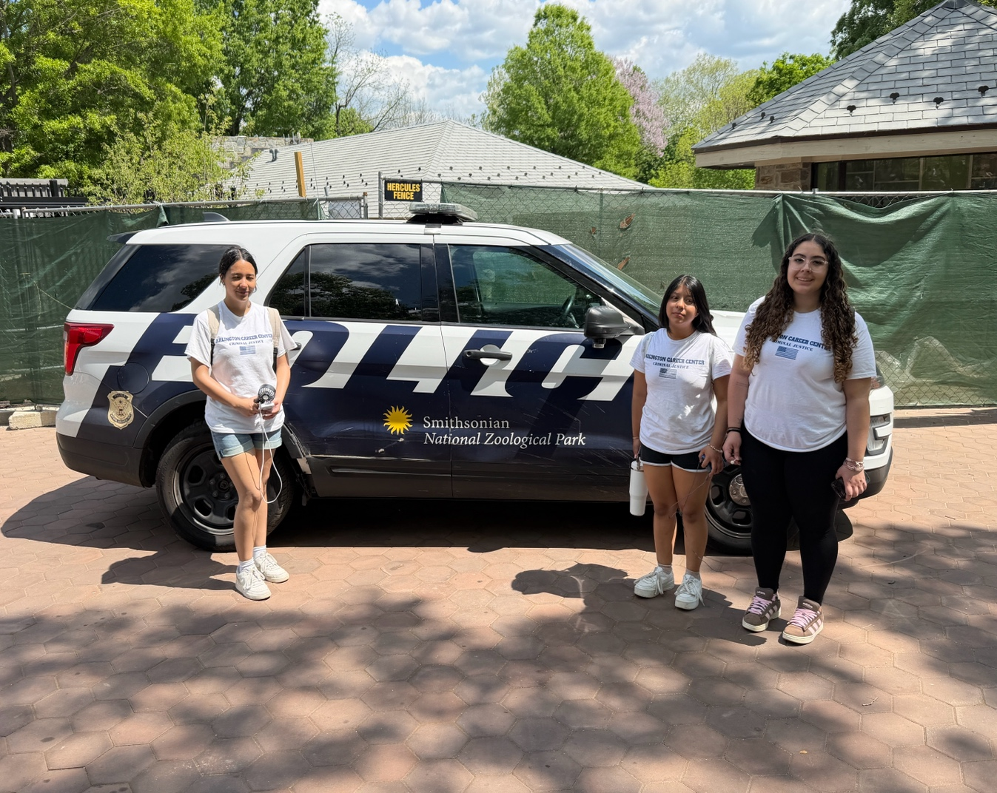

VIII. Analysis of Safety and Security Procedures
A central component of the research project was the structured analysis of the zoo's safety and security infrastructure. Students were tasked with evaluating the zoo's approach to security and comparing it to the security environments they had studied in traditional criminal justice contexts, including courthouses, K–12 schools, and large-scale public events. This comparative analysis challenged students to think critically about how security principles—deterrence, detection, delay, and response—are applied across different institutional settings.

A. Security Infrastructure Comparison Matrix
The following table presents a summary comparison developed by student research teams based on their on-site observations and classroom research:

Security Feature | Zoo Environment | Traditional Law Enforcement (Courthouse / School) | Large Public Event
Perimeter Security | Fencing with controlled vehicle and pedestrian entry points; natural barriers (water features, elevation) | Secure building perimeter; single controlled entry; metal detectors | Temporary fencing; multiple entry gates with ticket/credential checks
Surveillance Systems | CCTV at high-traffic areas, animal exhibits, and service zones; monitored centrally | CCTV throughout facility; real-time monitoring by security staff | Mobile camera units; drone surveillance at some events
Access Control | Ticketed public entry; credentialed staff access to restricted areas (animal care, veterinary) | ID verification; visitor logs; badge access for authorized personnel | Ticketed entry; VIP credentialing; backstage restricted zones
Personnel Presence | Uniformed zoo police; plainclothes security; animal care staff | Court officers; school resource officers; bailiffs | Private security; off-duty police; event staff
Emergency Response | Incident command structure; animal escape protocols; evacuation plans; coordination with local EMS | Lockdown procedures; active shooter drills; fire evacuation | Crowd crush protocols; medical tents; evacuation routes
Unique Considerations | Animal containment; chemical immobilization capability; wildlife law compliance; USDA inspection | Courtroom decorum; inmate transport; evidence security | Alcohol management; noise ordinances; temporary infrastructure

Students concluded that while the fundamental principles of security threat assessment, layered defense, and coordinated response are consistent across settings, the zoo environment introduces unique variables related to animal behavior, containment integrity, and regulatory compliance that are not present in traditional law enforcement contexts. The zoo's security model also places a greater emphasis on balancing openness (visitor experience) with restriction (animal and public safety), a tension that students found particularly instructive.

IX. Wildlife Law Connections
A foundational goal of the research project was to deepen students' understanding of the legal frameworks that govern wildlife protection and to connect those frameworks to core criminal justice concepts such as jurisdiction, enforcement authority, investigative procedure, and penalties. Through pre-trip instruction, on-site observation, and post-trip research, students developed a substantive understanding of four key pieces of legislation.

A. Key Federal Legislation

Legislation | Year Enacted | Key Provisions | Zoo-Level Relevance
Endangered Species Act (ESA) | 1973 | Provides framework for conservation of threatened and endangered species and their habitats; administered by U.S. Fish and Wildlife Service (FWS) and NMFS | Governs the zoo's acquisition, housing, and breeding of listed species; requires compliance with federal permits and recovery plans
Lacey Act | 1900 (amended) | Prohibits trafficking in illegally taken wildlife; imposes civil and criminal penalties; features a two-step offense structure requiring underlying violation and subsequent transaction | Relevant to the zoo's acquisition of animals and prevention of illegal trade; the zoo must verify legal provenance of all specimens
CITES | 1975 (entry into force) | International treaty governing cross-border trade in specimens of wild animals and plants; classifies species in three appendices based on trade risk | Governs international transfers of animals between zoos; requires CITES permits for import/export of listed species
Animal Welfare Act (AWA) | 1966 (amended) | Regulates the treatment of animals in exhibition, transport, and research; administered by USDA APHIS; establishes standards for housing, feeding, and veterinary care | Zoos are classified as exhibitors and must be licensed under the AWA; subject to regular USDA inspections for compliance

B. Criminal Justice Concepts in Wildlife Law
Students explored how several core criminal justice concepts manifest in the wildlife law context:
- Jurisdiction: Wildlife law enforcement involves overlapping federal, state, tribal, and international jurisdictions. Students observed that zoo compliance requires attention to multiple levels of legal authority simultaneously.
- Enforcement Authority: The U.S. Fish and Wildlife Service Office of Law Enforcement employs special agents, wildlife inspectors, intelligence analysts, and forensic scientists to investigate wildlife crimes and regulate trade. Students discussed how this specialized enforcement apparatus differs from general-purpose police forces.
- Investigative Procedures: Students examined how wildlife crime investigations employ techniques analogous to traditional criminal investigations, including surveillance, forensic analysis (e.g., DNA identification of species), undercover operations, and interagency task forces.
- Penalties: Students researched the penalty structures associated with violations of each statute, noting that criminal violations of the Lacey Act, for example, can carry felony-level penalties including imprisonment and substantial fines. This connected to classroom discussions about the purposes of punishment: deterrence, incapacitation, and retribution.
Students also investigated real-world cases of wildlife crime as part of their research. Examples included large-scale ivory trafficking prosecutions, illegal pet trade operations involving endangered reptiles, and cases involving the smuggling of protected animal parts such as a recent federal case in which an individual was sentenced for smuggling skulls, skins, and claws of protected species in violation of multiple federal and international laws. These case studies made the legal concepts concrete and demonstrated the seriousness with which wildlife crime is treated in the federal justice system.

X. Conservation Themes and Criminal Justice Intersections
The research project encouraged students to think beyond the boundaries of traditional criminal justice and to consider the role of law enforcement in environmental conservation. This interdisciplinary lens proved to be one of the most intellectually stimulating aspects of the project, prompting rich discussion about justice, equity, stewardship, and the public interest.

Law Enforcement and Conservation
Students explored the relationship between criminal justice and conservation through several thematic lenses. They examined anti-poaching initiatives in both domestic and international contexts, noting that the illegal wildlife trade is estimated to be one of the largest criminal enterprises in the world. They discussed how law enforcement agencies from local game wardens to international bodies like INTERPOL collaborate to combat wildlife crime through intelligence sharing, joint operations, and capacity building. Students recognized that the zoo itself plays a role in this broader ecosystem as a conservation institution, participating in species survival plans, captive breeding programs, and public education campaigns that raise awareness about the threats facing wildlife.

Community Education and the Zoo as Educator
Students observed that the zoo's educational displays and interpretive programming serve a crime-prevention function by informing the public about the laws that protect wildlife and the consequences of violating them. This observation connected to criminological theories studied in class, particularly the concept of general deterrence, the idea that the awareness of legal consequences can discourage criminal behavior in the general population. Students noted that the zoo's educational mission is, in this sense, aligned with the goals of the criminal justice system.

Environmental Justice and Equity
The project also prompted students to consider environmental justice the principle that all communities deserve equal protection from environmental harms and equal access to environmental benefits. Students discussed how wildlife crime disproportionately affects indigenous and rural communities in the Global South, where poaching and habitat destruction undermine local ecosystems and livelihoods. They connected these observations to broader themes of equity and justice that are central to the Criminal Justice II curriculum, recognizing that the criminal justice system has a role to play not only in punishing offenders but also in protecting vulnerable communities and ecosystems.

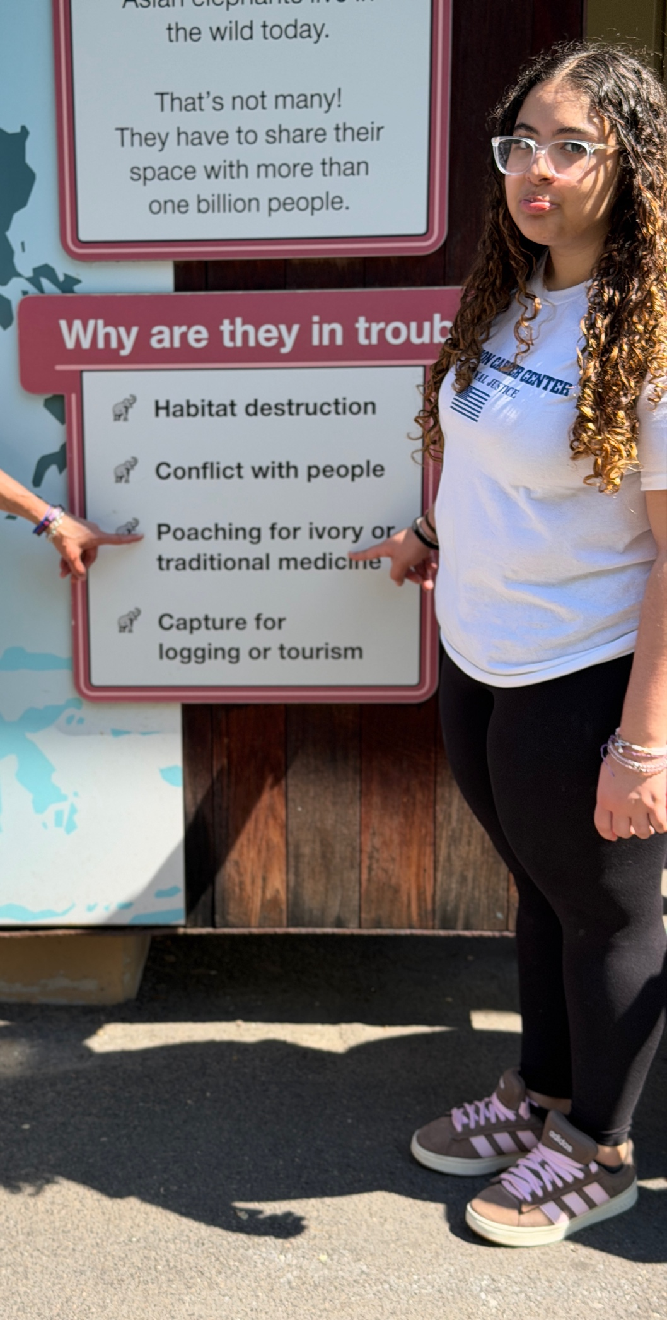

XI. Student Learning Outcomes and Reflection

A. Measured Outcomes
Assessment of student learning was conducted through a combination of formative and summative measures, including field observation logs, team research reports, individual reflection essays, and a post-experience knowledge assessment. The following outcomes were documented:

Learning Outcome | Evidence of Achievement
Deepened understanding of wildlife law | Students demonstrated accurate knowledge of key provisions of the ESA, Lacey Act, CITES, and AWA on the post-experience assessment, with an average score improvement of 34% compared to the pre-trip baseline.
Exposure to non-traditional CJ careers | In reflection essays, 92% of students reported that the field experience introduced them to career pathways they had not previously considered, including zoo law enforcement, wildlife inspection, and conservation enforcement.
Improved research and observation skills | Field observation logs demonstrated increasingly detailed and analytical entries over the course of the day, reflecting growth in observational rigor and descriptive precision.
Strengthened teamwork and communication | Team research reports reflected effective collaboration, with clear evidence of role fulfillment, information sharing, and synthesis across team members' contributions.
Enhanced critical thinking | Students' comparative analyses of zoo security and traditional law enforcement environments demonstrated the ability to identify patterns, draw inferences, and support conclusions with evidence.
Professional disposition development | Zoo staff and officers provided positive informal feedback on students' professionalism, respectful conduct, and quality of interview questions during the field experience.

B. Instructor Reflection

“As a curriculum developer and CTE instructor, I am continually seeking ways to bridge the gap between classroom theory and the professional world my students will enter. This project carried out that goal in ways that exceeded my expectations.”

Watching students engage with zoo police officers asking thoughtful questions, listening carefully, and making connections to material we had studied in class was one of the most rewarding moments of my teaching career. I observed students who had been reserved in the classroom come alive in the field, contributing observations and insights that demonstrated a level of understanding they had not previously expressed. The experiential format gave every student an entry point, regardless of their reading level, prior knowledge, or comfort with traditional assessment.
What struck me most was the way this project reinforced equity-centered education in practice, not just in principle. Every student in the class regardless of background, socioeconomic status, or prior exposure to professional environments had the same opportunity to interact with law enforcement professionals, observe sophisticated security systems, and investigate the real-world application of the laws we studied. For some students, this was their first visit to a zoological facility. For others, it was their first meaningful interaction with a law enforcement officer in a professional context. These experiences matter profoundly, and they are not equitably distributed in our society. As educators, we have a responsibility to create these opportunities intentionally.
Looking ahead, I see significant potential for expanding this project. The foundation we built this semester the research framework, the role structure, the partnerships with zoo staff can be refined and deepened in future iterations. I am particularly interested in exploring more formal partnerships with zoo education departments and with federal agencies such as the U.S. Fish and Wildlife Service, which could bring guest speakers and mentorship opportunities into our program.

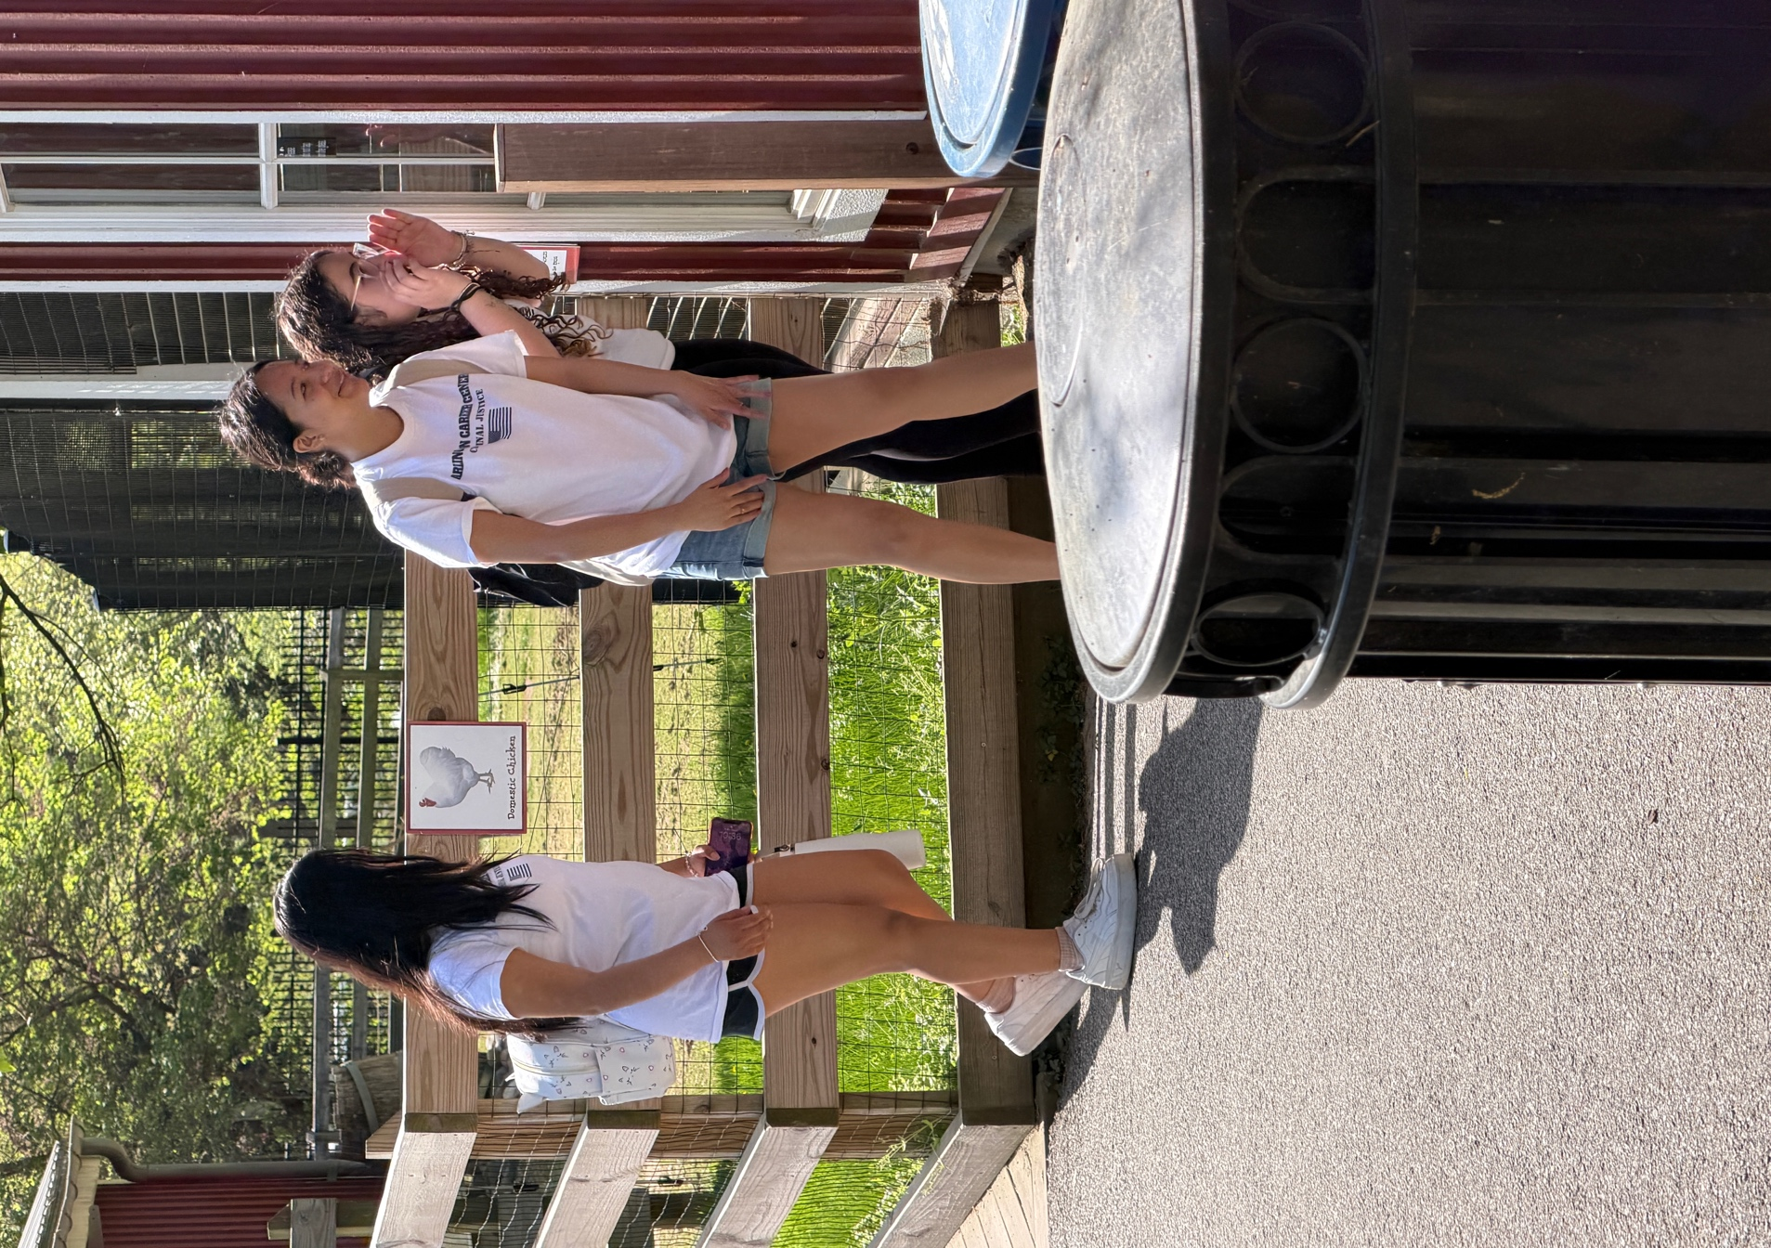

XII. Recommendations for Future Projects
Based on the outcomes and lessons learned from the Spring 2026 implementation, the following recommendations are offered for strengthening and expanding the zoo research project in future terms:
- Establish a Formal Partnership with the Zoo Education Department. A memorandum of understanding (MOU) with the zoo's education or outreach division would provide structured access to educational programming, behind-the-scenes tours, and coordinated interactions with zoo police. This partnership could also facilitate recurring visits and curriculum co-development.
- Incorporate Guest Speakers from Federal Agencies. Inviting representatives from the U.S. Fish and Wildlife Service, USDA APHIS, or state wildlife enforcement agencies to present in the classroom would deepen students' understanding of wildlife law enforcement careers and provide mentorship opportunities. Virtual guest speaker sessions could supplement in-person visits.
- Add a Mock Trial or Policy Brief Component. Extending the post-trip phase to include a mock trial based on a wildlife crime case study would allow students to apply legal reasoning, argumentation, and courtroom procedure skills. Alternatively, student teams could draft policy briefs recommending improvements to wildlife protection enforcement, combining research skills with persuasive writing.
- Expand to a Multi-Day or Multi-Site Experience. A two-day experience or visits to complementary sites such as a wildlife rehabilitation center, a federal wildlife forensics laboratory, or a Fish and Wildlife Service field office would provide richer data for comparative analysis and broader career exposure.
- Integrate Technology-Enhanced Documentation. Equipping student teams with tablets or digital field notebooks would streamline data collection and allow for real-time collaboration. A shared digital portfolio could serve as a cumulative artifact of the project across semesters, building an institutional knowledge base.
- Develop Student-Led Community Presentations. Requiring student teams to present their findings to community audiences such as school board meetings, parent nights, or community partner events would develop public speaking skills, increase program visibility, and demonstrate the value of CTE programming to stakeholders.

XIII. References
Association of Zoos and Aquariums. (n.d.). Safety & preparedness. https://www.aza.org/safety-preparedness
Barnum, C. J. (2025). Criminal Lacey Act offenses: An overview of selected issues (CRS Report No. R48669). Congressional Research Service. https://crsreports.congress.gov/product/pdf/R/R48669
Clark, R. W., Threeton, M. D., & Ewing, J. C. (2010). The potential of experiential learning models and practices in career and technical education and career and technical teacher education. Journal of Career and Technical Education, 25(2), 46–62.
Convention on International Trade in Endangered Species of Wild Fauna and Flora (CITES). (1973). Text of the Convention. https://cites.org/eng/disc/text.php
Endangered Species Act of 1973, 16 U.S.C. §§ 1531–1544 (1973).
Kolb, D. A. (2015). Experiential learning: Experience as the source of learning and development (2nd ed.). Pearson Education.
Lacey Act, 16 U.S.C. §§ 3371–3378 (1900, amended 2008).
Sheikh, P. A., & Ward, E. H. (2021). The Endangered Species Act: Overview and implementation (CRS Report No. R46677). Congressional Research Service. https://crsreports.congress.gov/product/pdf/R/R46677
U.S. Department of Agriculture, Animal and Plant Health Inspection Service. (2023). Animal Welfare Act and animal welfare regulations (APHIS 41-35-076). https://www.aphis.usda.gov/animal-welfare
U.S. Department of Justice, Environment and Natural Resources Division. (2015). Wildlife trafficking I. United States Attorneys’ Bulletin, 63(3).
U.S. Fish and Wildlife Service. (n.d.). Office of Law Enforcement. https://www.fws.gov/program/office-law-enforcement
U.S. Fish and Wildlife Service. (n.d.). Endangered Species Act. https://www.fws.gov/law/endangered-species-act
Virginia Department of Education. (n.d.). Career and Technical Education (CTE). https://www.doe.virginia.gov/teaching-learning-assessment/k-12-standards-instruction/career-and-technical-education-cte

XIV. Appendices

Appendix A: Student Research Question Worksheet

Purpose: To guide student inquiry before, during, and after the field experience.
Template Structure:
• Section 1 – Pre-Trip: Student name, team assignment, role, and assigned research question(s). Space for students to record background research, initial hypotheses, and planned observation strategies.
• Section 2 – On-Site: Structured fields for recording observations, evidence, and quotations from staff interviews related to each research question. Includes prompts: “What did you see that relates to your question?” and “What did you learn from staff interactions?”
• Section 3 – Post-Trip: Space for synthesizing findings, connecting observations to classroom content, and formulating conclusions. Includes a reflection prompt: “How did this experience change or deepen your understanding?”

Appendix B: Field Observation Log Template

Purpose: To standardize and structure student field notes for consistency and analytical rigor.
Template Fields:
Field
Description
Date / Time
Timestamp for each observation entry
Location within Zoo
Specific exhibit, area, or facility section
Observation
Detailed, objective description of what was seen, heard, or noted
Connection to Research Question
Which research question(s) this observation addresses
Analysis / Interpretation
Student's preliminary analysis or inference based on the observation
Follow-Up Needed
Questions to investigate further or clarify during post-trip research

Appendix C: Photo Documentation Log

Purpose: To catalog all visual evidence captured during the field experience with contextual information.
Template Fields:
Field
Description
Photo Number
Sequential identifier for each image
Date / Time Taken
Timestamp of the photograph
Location
Where in the zoo the photo was taken
Subject Description
What the photo depicts (e.g., “CCTV camera at main entrance gate”)
Relevance to Project
How the image connects to the research questions or analysis
Photographer
Name of the student who captured the image

Full appendix materials, including completed student worksheets and raw field notes, are available upon request.

Criminal Justice II: Zoo Research Project & Field Experience Report • Spring 2026 Prepared by Justin Rankin, M.L.A. • Criminal Justice CTE Instructor

